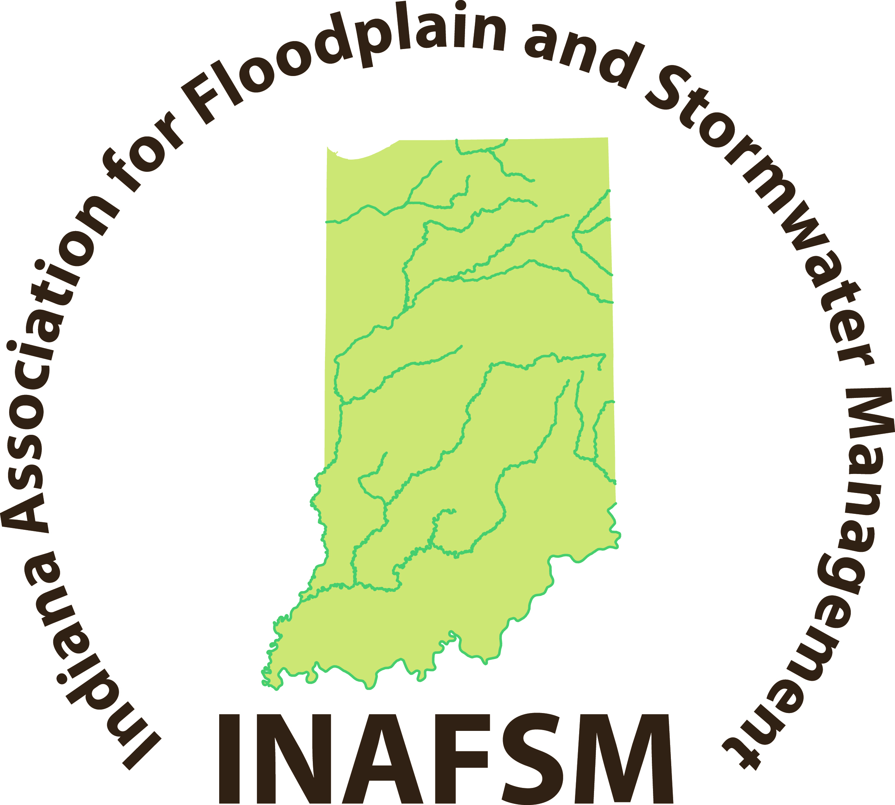
Indiana Association for Floodplain and Stormwater Management

2016 INAFSM Conference Scholarship Application

Submittal of this completed form must be made by Wednesday, April 20, 2016 and be submitted to kavery@inafsm.net

Applying for (Check one):
__ INAFSM Conference
__ StormCon
(For StormCon, please also attach official StormCon Registration Form)

Name/Title:
Organization:
Address:
Telephone while at conference:
Email:

Please check the following boxes:

INAFSM Member: ____ Yes ____ No Private Sector ____ Yes ____ No
Student: ____ Yes ____ No Non-Profit ____ Yes ____ No
Government: ___ Local ___State ___Federal

Certified Floodplain Manager: ___ Yes ___No
Stormwater Certifications: Please list

If a local public official, are you responsible for floodplain or stormwater management in your community? ____ Yes ____ No

If a local public official, has your community curtailed the reimbursement for attendance at conferences and professional development activities? ____ Yes ____ No

Have you previously attended the INAFSM Annual Conference? ____ Yes ____ No

Please answer on a separate piece of paper and let us know why we should select you for the scholarship.
- How will you use this scholarship opportunity to advance your career?
- How will you use this scholarship opportunity to benefit your community?
- Are you willing to serve on an INAFSM Committee for 1 year?
- Lastly and most importantly…Why do you want to attend the INAFSM Annual Conference and why should you be selected for this scholarship opportunity?

INAFSM membership must be current at time of submission. All applications will be verified for membership status before going to scholarship committee.

